Unit 24

Sound Editing Terminology

Assessment Terminology

Student Name: Aaron Ekpiteta 192234

Task 2

  - DAW 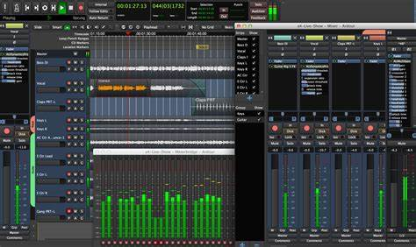
DAW stands for Digital Audio Workstation. Which is an electronic device or application software used for recording, editing and producing audio files. These are programs that work on desktops and laptops, we use logic pro to edit sound, it is a professional piece of software, and it runs on PC’s and MAC’s. However it relys on the computer to do the processing. DAW’s are digital products, they only edit sound digitally. They are cheap, logic cost between £3.00 - £5.00 monthly. Daws have a user friendly interface, this interface mimics a mixing desk, and logic can be used by a range of people from beginners to professionals. Daws are mobile. DAW’s have been around since the year 2000.
  - Mixing Desk 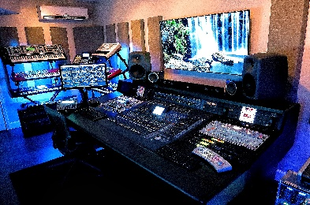
A mixing desk takes up a whole room, and this makes it immobile as it requires large pieces of equipment so it cannot be moved around freely. The room used for a mixing desk must be sound proof, and have air con. Mixing desks are usually quite expensive like they would cost a heavy £20,000 for a professional one. A mixing desk can be both analogue and digital, it is mainly used by professionals, and can be found in commercial music studios. A mixing desk mimics, edits, and mixes sound.
Components: master computer, separate slides & channels (slide + channel = mixer), headphones, sound proof recording room, microphone, air con, compressor & a sub. It is made of many expensive parts, so people would normally rent a studio and get a personal mixer to help with using the mixing desk.
  - My Opinion On DAWs and Recording Studios
In my opinion I would prefer to have a recording studio over a DAW like logic because firstly the general aesthetic of the recording studio suits me more because I like having that kind of equipment is highly professional. Another reason that I prefer recording studios is because computers can get viruses that can corrupt files whether its audio files or any other type of file but having a recording studio your audio files will have less of a chance to get corrupted. Lastly a recording studio has a more professional look to it than a DAW as music producers use recording studios to make there beats and songs, I would say that the DAW would be what a music producer would use if their abroad. A recording studio costs a lot more but provides you with professional equipment that can’t be lost or stolen. With a DAW the device your using it on can break but is cheaper than a recording studio. Overall I would say that a recording studio provides a better experience than with a DAW.
  - Cut
We used the cut technique to remove the stuff we don’t need like long pauses or any problems in speech. It determines the length of the audio.
  - Join/Fader tool 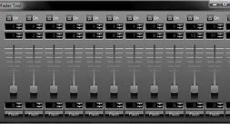
We join two separate sound files by cross-fading, if we don’t use cross-fade, we get an immediate jump and it blends the sounds together naturalising them.
  - Copy &Paste
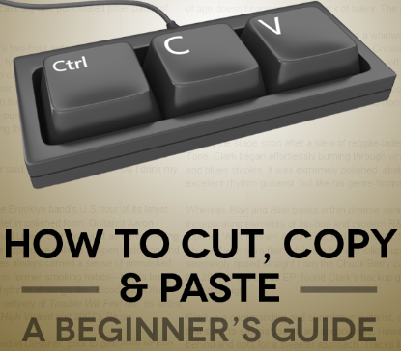
The shortcuts for these are ctrl + c (copy) & ctrl +v (paste). You may want the same sound played more than once, you can listen to the before and after the edits of the sound, its only issues or limitations are you might copy a mistake and used too many channels making your desk messy.

  - Stereo field
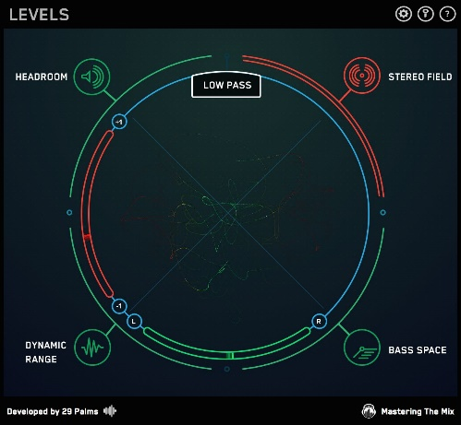
A Stereo field is the projected area of sound. You can control where the sound goes, by using a stereo field, makes the sound feel natural or this can be used to add an extra effect. The limitations are you need more than one speaker and a decent amount of space between them.
  - Mono
Mono means it has 1 source. This would be useful for dialogue in a film or for a music artist like singer or rapper a benefit would be that it just requires one speaker. A good example of a mono speaker would be an alarm.
  - Stereo sound

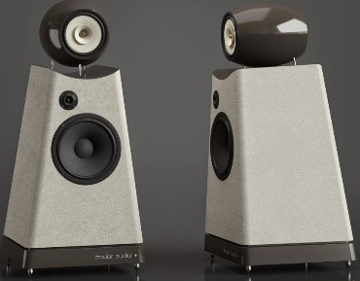
Stereo means two. Stereo sound is made with more than one speaker, we record audio in stereo mainly but it is more suited to musicians in bands. Six speakers are surround sound and its limitations you need more than one speaker and needs mixing.
  - Sound bite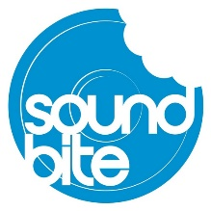
It is a small section from a larger audio file kind of like a quote. They are often the most key & relevant part of the whole audio file. They are used like a trailer is used for a film (to get you the viewer interested). There are often time restrictions on adverts. There may be copyright & licencing restrictions. The benefits are that they are concise and short and the limitation is that they can be misunderstood.
  - Automation
Automation is the same as an EQ but has control, over the selection of the mid, high & low frequencies. There is no analogue automation only digital automation. In logic you find this in the plugin section & you bus the sound through it. This is used for jobs with hours of footage then use an EQ to fine tune it.
  - Colour coding clips
We colour clips to differentiate between sound files & sound sources, you can only colour clip DAWs and it helps us identify individual sound sources.
  - Clipping
Clipping is where you put a marker on a sound file. You might mark significant changes you can colour code your mark.
  - EQ
An EQ digitally edits sound; it reduces the extreme high frequencies, low frequencies & boosts the middle frequencies. The boost increases the range of frequencies & makes it louder. On logic this is known as a plugin or you may bus sounds through a plugin. On an analogue mixing desk it is called a plugin but is a physical piece of hardware. They have many valves. Microphones pick up all frequencies all the same. An EQ naturalises normal sound, our brains pick up high & low frequencies naturally. You listen to the audio and tell the EQ is different. You have controls on the level used by the EQ. Frequencies, so it can adjust the sound. We naturalise sound to make the audio have a more believable and realistic sound.
  - Insertion of spaces in-between dialogue
  - Procedure 1: review recorded material before using it
Sound editing procedure from a digital recording to an mp3 using a DAW (Logic)
It tells us if the recording was of good quality, it tells us if what we have recorded is worth editing, it tells us if the recorder is working. Benefits; it can save you a lot of time in editing later, it can save time if you had to re-record. If this isn’t followed you may not meet the deadline, remove ambient noise & it may have a negative impact on the rest of the document. To fix it: record again, tell person to speak slower, put the microphone out of wind, re-locate and re-schedule.
  - Procedure 2: naming tracks and clips
Taking off recording device & saving on computer. Computers are safer to store the recordings. We name tracks so we can find them later. Benefits: naming tracks allows you to save time when searching. If not followed it could become lost and time is wasted, negative impact.
  - Factual Editing Process
Pre-recording: who will I interview and when I interview them how will it start and when it starts how long will it be, what questions will I ask, are they good enough questions to reflect my intensions. Pre edit check: listen back to the recording, have I asked enough questions, I’ll let the interviewee listen to the audio, is it clear enough. Edit: Editing to the time constraints, editing to my journalistic intension, taking away irrelevant content and changing the pitch of their voice to mask their identity. Post Edit: has freedom of speech been kept, have I bent the someone’s words or the truth, have I been lying.
This process was carried out in the documentary Blue Planet, where in the pre recording: David Attenborough sets up cameras in places to catch usual or interesting behaviour from the animals, pre-edit checks: Him and his team would watch the footage back and see what they should add to the final product, edit: In the edit section every scene going to be used would be add together to get the final video product and in post edit: David Attenborough’s will be added to the video in post, any sound effects will be added around this time as well and after putting it all together they would check the facts and see if it is all or mostly accurate so they are following ethical editing.
  - Fictional Editing Process
Pre-recording: Creative idea with creative intensions, this may come from me, or the producer, or the script writer Pre edit check: get the client to retake the audio, may decide to use different recorder so it sounds different, follow the creative process and do retakes. Edit: Creative process & creative intensions. May decide to go back to the client, is it what they expected, do they want a retake. Post edit: Legal freedom of speech am I persecuting 1 person or a group of people and does it meet the client brief.
This process was carried out in the sci-fi drama Timeless, where in the pre recording: they would storyboard the rules of time travel on the show, the story the season will have including the overarching story plot and they may also do run troughs of the script to see if there is anything to change, pre edit checks: they may retake the recording of the lines before editing if it doesn’t sound right when hearing it again, edit: they may cut certain scenes that may not make sense, in the post edit: the Foley sfx would be added to the episodes and any last minutes checks will take place that could delay the release of the episode. Ethical editing checks will be made as well to be sure that freedom of speech is kept.

